Using lags:

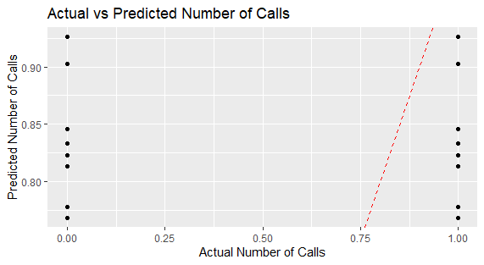

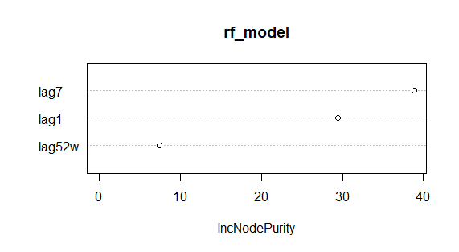

Modified data structure:

Model with holidays:

